Q1)

<html>

    <head>

        <title>Q 1</title>

    </head>

    <body>

        <h3 style="text-align: center;font-family:cursive;">A test table with merged cells</h3>

        <table align="center" style="text-align: center;width: 40%;height: 40%;" border="10">

            <tr>

                <th rowspan="2">&ensp;&ensp;&ensp;&ensp;&ensp;&ensp;</th>

                <th colspan="2">Average</th>

                <th rowspan="2">Red eyes</th>

            </tr>

            <tr>

                <th>height</th>

                <th>weight</th>

            </tr>

            <tr>

                <th>Males</th>

                <td style="text-align: left;">&ensp;1.9</td>

                <td style="text-align: left;">&ensp;0.003</td>

                <td style="text-align: left;">&ensp;40%</td>

            </tr>

            <tr>

                <th>Females</th>

                <td style="text-align: left;">&ensp;1.7</td>

                <td style="text-align: left;">&ensp;0.002</td>

                <td style="text-align: left;">&ensp;43%</td>

            </tr>

        </table>

    </body>

</html>

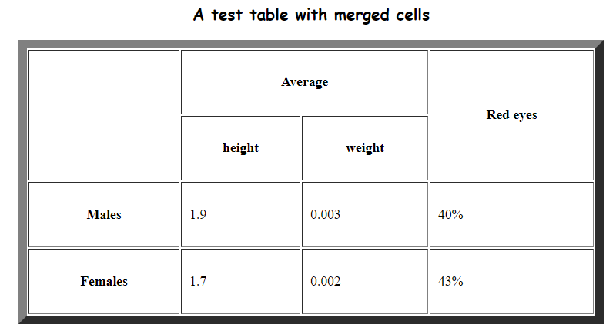

Q2)

<html>

    <head>

        <title>Q 2</title>

    </head>

    <body>

        <table style="width: 40%;height: 40%;text-align: center;border-color: white;" border="10" align="center">

            <tr style="background-color: grey;">

                <td colspan="5">My Multi Level Table</td>

            </tr>

            <tr>

                <th rowspan="2" colspan="2">Column 0</th>

                <th rowspan="2">Column 1</th>

                <th colspan="2">Column 2</th>

            </tr>

            <tr>

                <th>Column 2a</th>

                <th>Column 2b</th>

            </tr>

            <tr>

                <th rowspan="2">Row 1</th>

                <th>Row 1a</th>

                <td>123</td>

                <td>456</td>

                <td>789</td>

            </tr>

            <tr>

                <th>Row 1b</th>

                <td>123</td>

                <td>456</td>

                <td>789</td>

            </tr>

            <tr>

                <th colspan="2">Row 2</th>

                <td>123</td>

                <td>456</td>

                <td>789</td>

            </tr>

        </table>

    </body>

</html>

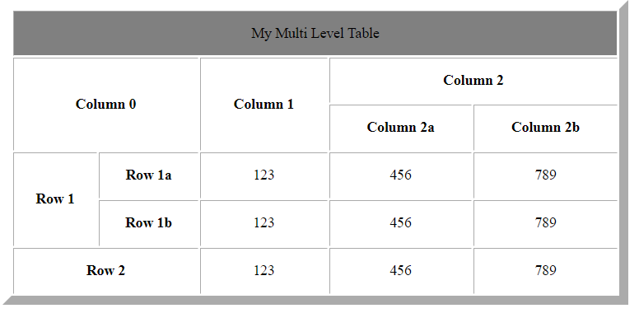

Q3)

<html>

    <head>

        <title>Q 3</title>

    </head>

    <body>

        <table style="width: 40%;height: 40%;text-align: center;border-color: black;" align="center" border="5" cellspacing="0">

            <tr>

                <th colspan="8">TITLE</th>

            </tr>

            <tr>

                <th colspan="4">subtitle</th>

                <th colspan="4">subtitle</th>

            </tr>

            <tr>

                <th colspan="2" rowspan="3" style="width: 25%;">1 item <br><br>1 item <br><br>1 item </th>

                <th colspan="2" rowspan="3" style="width: 25%;">123 <br><br>123 <br><br>123 </th>

                <th colspan="2" rowspan="3" style="width: 25%;">1 item <br><br>1 item <br><br>1 item </th>

                <th colspan="2" rowspan="3" style="width: 25%;">123 <br><br>123 <br><br>123 </th>

            </tr>

            <tr></tr>

            <tr></tr>

            <tr>

                <th colspan="8">sub subtitle</th>

            </tr>

        </table>

    </body>

</html>

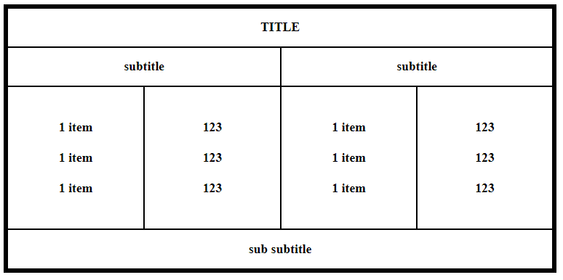

Q4)

<html>

    <head>

        <title>Q 4</title>

    </head>

    <body>

        <table style="width: 30%;height: 30%;text-align: center;" border="10" align="center">

            <tr>

                <td>Columu 1</td>

                <td>Columu 2</td>

                <td>Columu 3</td>

            </tr>

            <tr>

                <td rowspan="2"> Row 1 Cell 1</td>

                <td>Row 1 Cell 2</td>

                <td>Row 1 Cell 3</td>

            </tr>

            <tr>

                <td>Row 1 Cell 2</td>

                <td>Row 1 Cell 3</td>

            </tr>

            <tr style="text-align: left;">

            <td colspan="3">Row 3 Cell 1</td></tr>

        </table>

    </body>

</html>

